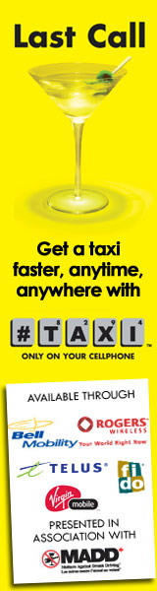
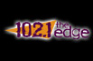
Hey Bon
The Dean Blundell Holiday Sale, presented by Sunrise Records comes to a close this Friday. COME DOWN TO OUR STUDIO before Friday and get cool stuff for your friends and family!!!! Check out the list right here. Plus, we just got Green Day barstools in. Unbelievable! Don't forget, 25% of the sales go to Ronald McDonald House Charities. Shopping at our street level studio at 228 Yonge Street = good holiday karma!
Also coming to a close this weekend is the incredibly successful Edge Electric Xmas Concert Series, in concert with Vonage Canada. We have Neverending White Lights shows going tomorrow, Friday, and Saturday and then it's all wrapped up in time for Xmas. If you went to any one of the Edge Electric Xmas shows, than you raised some money for the Daily Bread Food Bank, and that is a really good thing.
You like Evanescence? Check out how giant this contest we're doing is.
My Xmas list includes Optimus Prime. He is the leader of the Autobots and comes from Cybertron, you know. Am I a little nerdy?
What's on your list?
Happy Holidays to you and yours.
js

If you don't want to receive these emails anymore, just click here, log in and update your profile settings.

